Name:
NAAP – Cosmic Distance Ladder 1/7
The Cosmic Distance Ladder – Student Guide Exercises
The Cosmic Distance Ladder Module consists of material on seven different distance determination techniques. Four of the techniques have external simulators in addition to the background pages. You are encouraged to work through the material for each technique before moving on to the next technique.
Radar Ranging
Question 1: Over the last 10 years, a large number of iceballs have been found in the
outer solar system out beyond Pluto. These objects are collectively known as the Kuiper Belt. An amateur astronomer suggests using the radar ranging technique to learn the
rotation periods of Kuiper Belt Objects. Do you think that this plan would be
successful? Explain why or why not?
Parallax
In addition to astronomical applications, parallax is used for measuring distances in many other disciplines such as surveying. Open the Parallax Explorer where techniques very similar to those used by surveyors are applied to the problem of finding the distance to a boat out in the middle of a large lake by finding its position on a small scale drawing of the real world. The simulator consists of a map providing a scaled overhead view of the lake and a road along the bottom edge where our surveyor represented by a red X may be located. The surveyor is equipped with a theodolite (a combination of a small telescope and a large protractor so that the angle of the telescope orientation can be precisely measured) mounted on a tripod that can be moved along the road to establish a baseline. An Observer’s View panel shows the appearance of the boat relative to trees on the far shore through the theodolite.
Configure the simulator to preset A which allows us to see the location of the boat on the map. (This is a helpful simplification to help us get started with this technique – normally the main goal of the process is to learn the position of the boat on the scaled map.) Drag the position of the surveyor around and note how the apparent position of the boat relative to background objects changes. Position the surveyor to the far left of the road and click take measurement which causes the surveyor to sight the boat through the theodolite and measure the angle between the line of sight to the boat and the road. Now position the surveyor to the far right of the road and click take measurement again. The distance between these two positions defines the baseline of our observations and the intersection of the two red lines of sight indicates the position of the boat.

We now need to make a measurement on our scaled map and convert it back to a distance in the real world. Check show ruler and use this ruler to measure the distance from the baseline to the boat in an arbitrary unit. Then use the map scale factor to calculate the perpendicular distance from the baseline to the boat.

NAAP – Cosmic Distance Ladder 2/7
Question 2: Enter your perpendicular distance to the boat in map units.
Show your calculation of the distance to the boat in meters in the box below.
Configure the simulator to preset B. The parallax explorer now assumes that our surveyor can make angular observations with a typical error of 3°. Due to this error we will now describe an area where the boat must be located as the overlap of two cones as opposed to a definite location that was the intersection of two lines. This preset is more realistic in that it does not illustrate the position of the boat on the map.
Question 3: Repeat the process of applying triangulation to determine the distance to the boat and then answer the following:
What is your best estimate for the
perpendicular distance to the boat?
What is the greatest distance to the boat
that is still consistent with your
observations?
What is the smallest distance to the boat
that is still consistent with your
observations?

Configure the simulator to preset C which limits the size of the baseline and has an error of 5° in each angular measurement.
Question 4: Repeat the process of applying triangulation to determine the distance to the boat and then explain how accurately you can determine this distance and the factors
contributing to that accuracy.

Distance Modulus
NAAP – Cosmic Distance Ladder 3/7
Question 5: Complete the following table concerning the distance modulus for several objects.
Object | Apparent  Magnitude  m | Absolute  Magnitude  M | Distance  Modulus  m-M | Distance  (pc)
Star A | 2.4 |  |  | 10
Star B |  | 5 |  | 16
Star C | 10 |  |  | 25
Star D | 8.5 | 0.5

Question 6: Could one of the stars listed in the table above be an RR Lyrae star? Explain
why or why not.
Spectroscopic Parallax
Open up the Spectroscopic Parallax Simulator. There is a panel in the upper left entitled Absorption Line Intensities – this is where we can use information on the types of lines in a star’s spectrum to determine its spectral type. There is a panel in the lower right entitled Star Attributes where one can enter the luminosity class based upon information on the thickness of line in a star’s spectrum. This is enough information to position the star on the HR Diagram in the upper right and read off its absolute magnitude.
Let’s work through an example. Imagine that an astronomer observes a star to have an apparent magnitude of 4.2 and collects a spectrum that has very strong helium and moderately strong ionized helium lines – all very thick. Find the distance to the star using spectroscopic parallax.

Let’s first find the spectral type. We can see in the Absorption Line Intensities panel that for the star to have any helium lines it must be a very hot
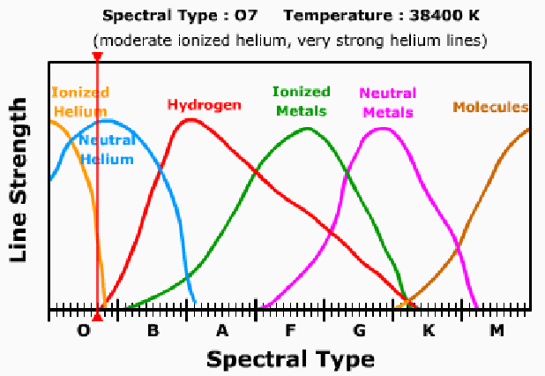
NAAP – Cosmic Distance Ladder 4/7
blue star. By dragging the
vertical cursor we can see that for the star to have very strong helium and moderate ionized helium lines it must either be O6 or O7. Since the spectral lines are all very thick, we can assume that it is a main sequence star. Setting the star to luminosity
class V in the Star Attributes panel then determines its position on the HR Diagram and identifies its absolute magnitude as -4.1. We can complete the distance modulus
calculation by setting the apparent magnitude slider to 4.2 in the Star Attributes panel.
The distance modulus is 8.3 corresponding to a distance of 449 pc. Students should keep in mind that spectroscopic parallax is not a particularly precise technique even for
professional astronomers. In reality, the luminosity classes are much wider than they are shown in this simulation and distances determined by this technique are probably have uncertainties of about 20%.
Question 7: Complete the table below by applying the technique of spectroscopic parallax.
Observational Data |  |  | Analysis
m | Description of spectral lines | Description of line thickness | M | m-M | d  (pc)
6.2 | strong hydrogen lines  moderate helium lines | very thin
13.1 | strong molecular lines | very thick
7.2 | strong ionized metal lines  moderate hydrogen lines | very thick

Main Sequence Fitting
NAAP – Cosmic Distance Ladder 5/7
Open up the Cluster Fitting Explorer. Note that the main sequence data for nearby stars whose distances are known are plotted by absolute magnitude in red on the HR Diagram. In the Cluster Selection Panel, choose the Pleiades cluster. The Pleiades data are then added in apparent magnitude in blue. Note that the two y-axes are aligned, but the two main sequences don’t overlap due to the distance of the Pleiades (since it is not 10 parsecs away).
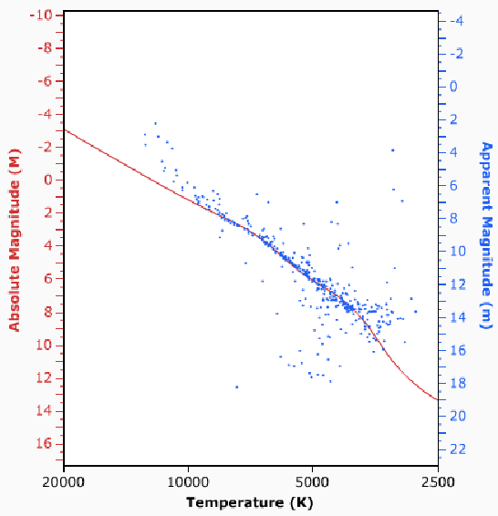
If you move the cursor into the HR diagram, the cursor will change to a handle, and you can shift the apparent magnitude scale by clicking and dragging. Grab the cluster data and drag it until the two main sequences are best overlapped as shown to the right.
We can now relate the two y-axes. Check show horizontal bar which will automate the process of determining the offset between the m and M axes. Note that it doesn’t matter where you compare the m and M values, at all points they will give the proper distance modulus. One set of values gives m – M = 1.6 – (-4.0) = 5.6 which corresponds to a distance of 132 pc.
Question 8: Note that there are several stars that are above the main sequence in the
upper left. Can you explain why these stars are not on the main sequence?
Question 9: Note that there are several stars below the main sequence especially near temperatures of about 5000K. Can you explain why these stars are not on the main
sequence?

Question 10: Determine the distance to the Hyades cluster.

NAAP – Cosmic Distance Ladder 6/7
Question 11: Determine the distance to the M67 cluster.

Apparent magnitude m
Absolute Magnitude M
Distance (pc)
Cepheids

Apparent magnitude m
Absolute Magnitude M
Distance (pc)
Question 12: A type II Cepheid has an apparent magnitude of 12 and a pulsation period of 3 days. Determine the distance to the Cepheid variable and explain your method in the box below?
Supernovae
Open up the Supernovae Light Curve Explorer. It functions similarly to the Cluster Fitting Explorer. The red line illustrates the expected profile for a Type I supernovae in terms of Absolute Magnitude. Data from various supernovae can be graphed in terms of apparent magnitude. If the data represents a Type I Supernovae it should be possible to fit the data to the Type I profile with the appropriate shifts in time and magnitude. Once the data fit the profile, then the difference between apparent and absolute magnitude again gives the distance modulus.
As an example load the data for 1995D. Grab and drag the data until it best matches the Type I profile as shown. One can then use the show horizontal bar option to help calculate the distance modulus. One pair of values is m – M = 13-(-20) = 33 which corresponds to a distance of 40 Mpc.

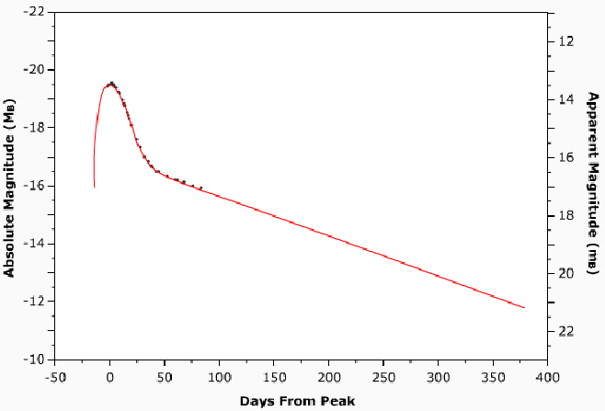
Question 13: Determine the distance to Supernovae 1994ae and explain your method in the box below?

NAAP – Cosmic Distance Ladder 7/7
Question 14: Load the data for Supernova 1987A. Explain why it is not possible to
determine the distance to this supernova?

