The Cosmic Distance Ladder
There are at least seven different astronomical distance determination techniques:
-- radar ranging,
-- parallax,
-- distance modulus,
-- spectroscopic parallax,
-- main sequence fitting,
-- Cepheid variables, and
--supernovae

On Monday February 25, 2013 we will only look at parallax while distance modulus and spectroscopic parallax are also given below.

Parallax

In addition to astronomical applications, parallax is used for measuring distances in many other disciplines such as surveying.

http://astro.unl.edu/naap/distance/animations/parallaxExplorer.html

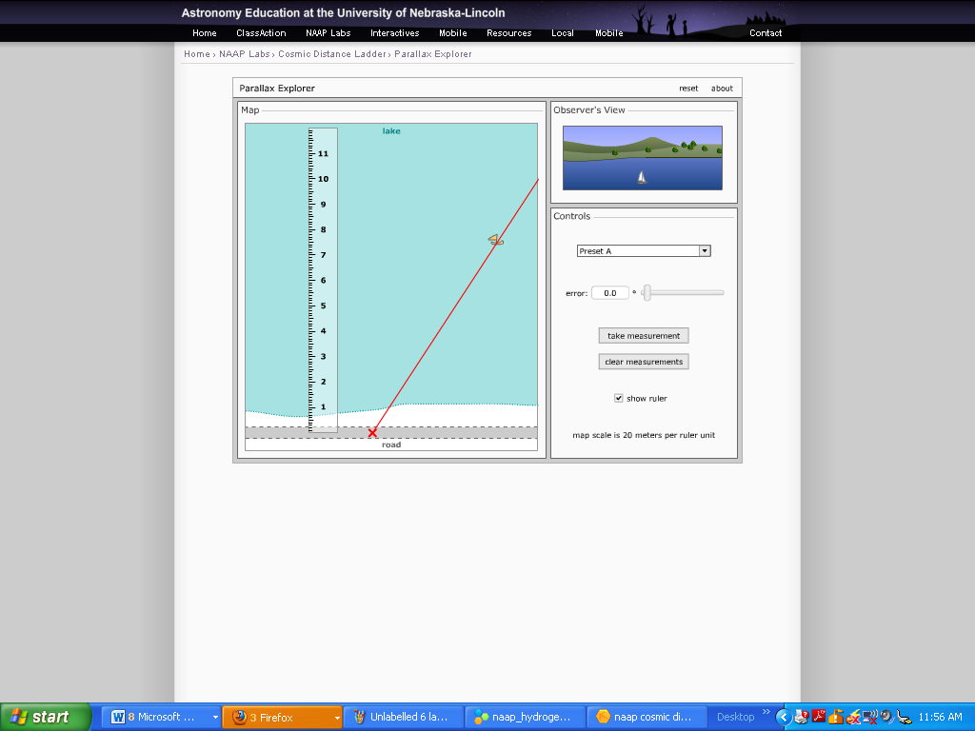

Open the Parallax Explorer where techniques very similar to those used by surveyors are applied to the problem of finding the distance to a boat out in the middle of a large lake by finding its position on a small scale drawing of the real world. The simulator consists of a map providing a scaled overhead view of the lake and a road along the bottom edge where our surveyor represented by a red X may be located. The surveyor is equipped with a theodolite (a combination of a small telescope and a large protractor so that the angle of the telescope orientation can be precisely measured) mounted on a tripod that can be moved along the road to establish a baseline. An Observer’s View panel shows the appearance of the boat relative to trees on the far shore through the theodolite.
Configure the simulator to preset A which allows us to see the location of the boat on the map. (This is a helpful simplification to help us get started with this technique – normally the main goal of the process is to learn the position of the boat on the scaled map.) Drag the position of the surveyor around and note how the apparent position of the boat relative to background objects changes. Position the surveyor to the far left of the road and click take measurement which causes the surveyor to sight the boat through the theodolite and measure the angle between the line of sight to the boat and the road. Now position the surveyor to the far right of the road and click take measurement again. The distance between these two positions defines the baseline of our observations and the intersection of the two red lines of sight indicates the position of the boat.
We now need to make a measurement on our scaled map and convert it back to a distance in the real world. Check show ruler and use this ruler to measure the distance from the baseline to the boat in an arbitrary unit. Then use the map scale factor to calculate the perpendicular distance from the baseline to the boat.

Question 2: Enter your perpendicular distance to the boat in map units.
Show your calculation of the distance to the boat in meters in the box below.
Configure the simulator to preset B. The parallax explorer now assumes that our surveyor can make angular observations with a typical error of 3°. Due to this error we will now describe an area where the boat must be located as the overlap of two cones as opposed to a definite location that was the intersection of two lines. This preset is more realistic in that it does not illustrate the position of the boat on the map.
Question 3: Repeat the process of applying triangulation to determine the distance to the boat and then answer the following:
What is your best estimate for the
perpendicular distance to the boat?
What is the greatest distance to the boat
that is still consistent with your
observations?
What is the smallest distance to the boat
that is still consistent with your
observations?

Configure the simulator to preset C which limits the size of the baseline and has an error of 5° in each angular measurement.

Question 4: Repeat the process of applying triangulation to determine the distance to the boat and then explain how accurately you can determine this distance and the factors
contributing to that accuracy.

Distance Modulus
Question 5: Complete the following table concerning the distance modulus for several objects.
Object | Apparent  Magnitude  m | Absolute  Magnitude  M | Distance  Modulus  m-M | Distance  (pc)
Star A | 2.4 |  |  | 10
Star B |  | 5 |  | 16
Star C | 10 |  |  | 25
Star D | 8.5 | 0.5

Question 6: Could one of the stars listed in the table above be an RR Lyrae star? Explain
why or why not.
Spectroscopic Parallax
Open up the Spectroscopic Parallax Simulator. There is a panel in the upper left entitled Absorption Line Intensities – this is where we can use information on the types of lines in a star’s spectrum to determine its spectral type. There is a panel in the lower right entitled Star Attributes where one can enter the luminosity class based upon information on the thickness of line in a star’s spectrum. This is enough information to position the star on the HR Diagram in the upper right and read off its absolute magnitude.
http://astro.unl.edu/naap/distance/animations/spectroParallax.html

Let’s work through an example. Imagine that an astronomer observes a star to have an apparent magnitude of 4.2 and collects a spectrum that has very strong helium and moderately strong ionized helium lines – all very thick. Find the distance to the star using spectroscopic parallax.

Let’s work through an example. Imagine that an astronomer observes a star to have an apparent magnitude of 4.2 and collects a spectrum that has very strong helium and moderately strong ionized helium lines – all very thick. Find the distance to the star using spectroscopic parallax.

Let’s first find the spectral type. We can see in the Absorption Line Intensities panel that for the star to have any helium lines it must be a very hot
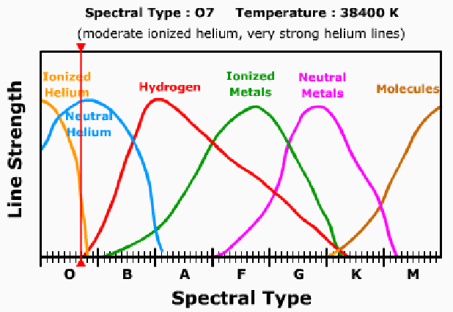
blue star. By dragging the
vertical cursor we can see that for the star to have very strong helium and moderate ionized helium lines it must either be O6 or O7. Since the spectral lines are all very thick, we can assume that it is a main sequence star. Setting the star to luminosity
class V in the Star Attributes panel then determines its position on the HR Diagram and identifies its absolute magnitude as -4.1. We can complete the distance modulus
calculation by setting the apparent magnitude slider to 4.2 in the Star Attributes panel.
The distance modulus is 8.3 corresponding to a distance of 449 pc. Students should keep in mind that spectroscopic parallax is not a particularly precise technique even for
professional astronomers. In reality, the luminosity classes are much wider than they are shown in this simulation and distances determined by this technique are probably have uncertainties of about 20%.
Question 7: Complete the table below by applying the technique of spectroscopic parallax.
Observational Data |  |  | Analysis
m | Description of spectral lines | Description of line thickness | M | m-M | d  (pc)
6.2 | strong hydrogen lines  moderate helium lines | very thin
13.1 | strong molecular lines | very thick
7.2 | strong ionized metal lines  moderate hydrogen lines | very thick

Cepheid Variables http://astro.unl.edu/naap/distance/cepheids.html
Cepheid variables are pulsating variable stars similar to the RR Lyraes mentioned earlier on the distance modulus page. However, Cepheids have longer pulsation periods and they are larger stars. Cepheids have been extremely important as distance indicators for many years. Although they don’t all have the same average absolute magnitude as RR Lyraes do, they are more useful since they are brighter stars and can be observed at greater distances.
Henrietta Leavitt in 1912 was the first to recognize that there was a relationship between the pulsation periods and the luminosities of Cepheids. She recognized that larger, brighter Cepheids have longer pulsation periods, although she was unaware of the exact relationship. Harlow Shapley later calibrated the Cepheids – relating the periods of pulsation to the absolute magnitudes which led to the first estimate of the size of the Milky Way. The calibration of the period-luminosity relationship has improved over time and a modern version is depicted in the figure to the right.

To the left is a graph of the periodicity of the Type I (high-metallicity) Cepheid variable S Nor. Cepheid S Nor has a period of pulsation of approximately 10 days and an average apparent magnitude m_{V} = 6.5, what is its distance? We can use the pulsation period to estimate the absolute magnitude of the Cepheid. From the chart above a period of 10 days corresponds to an absolute magnitude of -4. Thus, the distance modulus is m - M = 6.5 - (-4) = 10.5, which corresponds to a distance of 1260 pc. Note that our estimate is not particularly accurate since we didn’t take into account many subtleties that research astronomers would consider.
Because of the brightnesses of Cepheids, astronomers can identify them in nearby galaxies. Observations of Cepheids by the Hubble Space Telescope have recently been used to estimate the distance to the Virgo Cluster which is about 18 Mpc

THE END

